SFI 2024, March 2024, Rezekne, Latvia
Article Title
Name Surname ª, Name Surname ^{b}, Name Surname ^{c}, Name Surname ^{d}, Name Surname ª, Name Surname ª
ªRezekne Academy of Technologies, Atbrivošanas str.115, Rezekne, LV-4601, Latvia
^{b}Manchester Metropolitan University, Cavendish Str., Manchester, M16 GB6, United Kingdom
^{c}Latvia University of Life Sciences and Technologies, Lielā str. 2, Jelgava, LV-3001, Latvia
^{d}Riga Technical University, Kaļķu str.1, Riga, LV-1658, Latvia
Abstract
Give a concise summary (less than 3000 characters) of the paper: research focus, research methods used, the results and the main conclusions and recommendations. Use this document as a template if necessary or follow the instructions below to compose your manuscript. This electronic document is a “live” template and already defines the components of your paper [title, text, heads, etc.] in its style sheet. *CRITICAL: Do Not Use Symbols, Special Characters, Footnotes, or Math in Article Title or Abstract.

Keywords: Choose up to four key words or phrases and locate them in alphabetical order just after the abstract of your paper, separated by commas. Keywords ensure the most precise insight into the issue of an article. Please add 3-5 key words. A phrase or a word combination counts as 1 keyword.
- Introduction
This document provides instructions for preparing manuscripts for publishing in the journal “Sustainable Food Industry” at Rezekne Academy of Technologies. The document is also a sample of layout for the manuscripts submitted for publication.
The copyright of articles is transferred to the Rezekne Academy of Technologies. Articles will be published under Creative Commons Attribution 4.0 International License.
All submissions must meet the following requirements:
- The submission has not been previously published, nor is it before another journal for consideration (or an explanation has been provided in Comments to the Editor).
- The submission file is in Microsoft Word only.
- The file should show the author’s name and affiliation the font required is Times New Roman; the font size is 12 pt.; line spacing – 1,15 pt, center).
- The text adheres to the stylistic and bibliographic requirements outlined in the Author Guidelines.
- Articles should be formatted as follows: the font required is Times New Roman; the font size is 10 pt.; line spacing – 1,0 pt.; spacing after/before paragraphs – 6 pt. The body text should consist of paragraphs with 0,6 cm indentation. The text should be justified.
The structure of manuscripts:
- Abstract,
- Key words,
- Introduction,
- Materials and methods,
- Results and discussion,
- Conclusions,
- Acknowledgments,
- References.
The manuscript should be submitted to in an electronic format. Prepare the manuscript with Microsoft Word. The recommended length of the manuscript is 5-10 pages limitations, including information about the authors, abstract and images. When writing the manuscript use Times New Roman font.
Use Spell check. If you do use them, do not number Acknowledgment and References, and arrange subheadings with letters.
- Materials and Methods
Can have no more than 6 authors. Author names should be listed starting from left to right. Names should not be listed in columns nor group by affiliation. Please keep your affiliations as succinct as possible (for example, do not differentiate among departments of the same organization).
- Results and discussion
Preferable options for graphic images and photographs are: 300 dpi resolution, 8 bits per pixel, gray/colorscale.
It must be noted that all the papers will be printed using grayscale printing technology.
Place figures and tables at the top and bottom of columns. Avoid placing them in the middle of columns. Large figures and tables may span across both columns. Figure captions should be below the figures; table heads should appear above the tables. Insert figures and tables after they are cited in the text. Use the abbreviation “Fig. 1”, even at the beginning of a sentence.
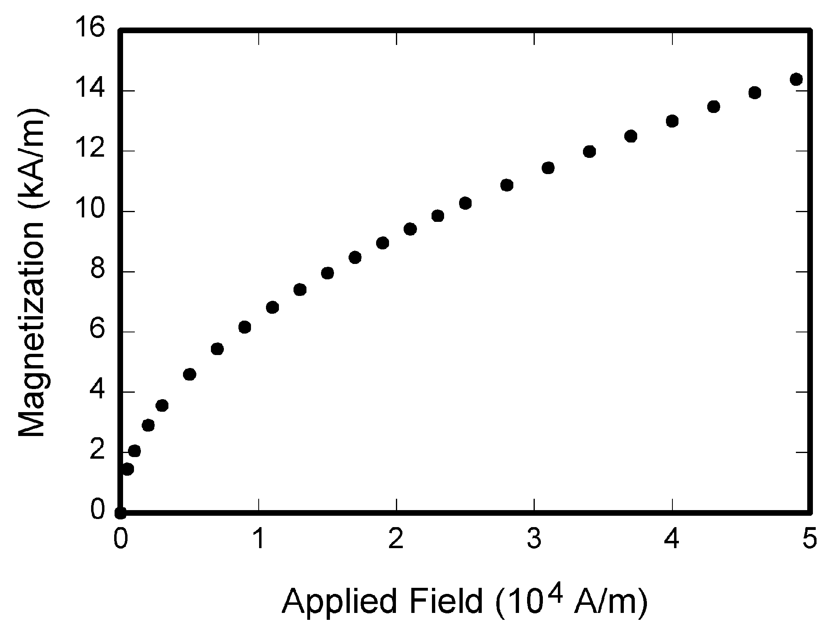
- Magnetization as a function of applied field.
If your figure has two parts, incorporate the labels “(a)” and “(b)” in the figure. At the same time, do not incorporate captions in the figures. Do not put captions in “text boxes” linked to the figures. Do not put borders around the outside of your figures. Use the abbreviation “Fig. 1” even at the beginning of a sentence.
Table captions and titles should always be right aligned and placed above the tables. Tables are numbered consecutively with Roman numerals and have reference in the main text.

Table 1 Type Styles
Table Head | Table Head | Table Head | Table Column Head
Table Head | Table Head | Table Head | Table column subhead | Subhead | Subhead
1st row | copy | 100 | More t able copy | 4.47 | copy
2nd row | copy | 20 | copy | 100.00 | Copy
3rd row | copy | 3 | More table copy | 3.52 | copy
4th row | copy | 7 | More table copy | 3.78 | copy

All cells in the table must be filled. One table should not be smaller than 4 or larger than 10 rows. Numbers of the same precision must be used in one column.

Table 2 Type Styles
Table Head | Table Head | Table Column Head |  |  | Table Head | Table Head | Table Head
Table Head | Table Head | Table column subhead | Subhead | Subhead | Table Head | Table Head | Table Head
copy | copy | More table copy | copy | copy | copy | copy | Copy
copy | copy | More table copy | copy | copy | copy | copy | Copy
copy | copy | More table copy | copy | copy | copy | copy | Copy
copy | copy | More table copy | copy | copy | copy | copy | Copy

Use the equation editor to create your equations. Place one tab before short equations to center them and one or two tabs after the equations to put equation’s number flush with the right margin, as in (1). Number the equations consecutively.

$c^{2}=a^{2}+b^{2}$ (1)

The size of basic symbols in equations should correspond to the letter size of the main text (10pt). Use “(1)” not “Eq. (1)” or “equation (1)”.
The body text includes the textual part and references. The body text can be structured using subtitles in Italic and Bold.
- Special terms and foreign words should be in Italic.
- For emphasis, please use bold.
- Quoted text should be in Italic.
- Work titles should be in Italic and without inverted commas.

Programs and Codes
If necessary, include parts or entire texts of your programs following the “Programs and Codes” style or using “New Courier” font. Try to fit such texts in one column.
void main(void)
{
WDTCTL = WDTPW + WDTHOLD; //Stop watchdog
P3DIR |= 0x01; //P3.0 - output
for (;;)
{ unsigned int i;
i = 50000;
do i--;while (i != 0); // Delay
P3OUT ^= 0xFF; } //Toggle P3.0
}
Wide programs may span across both columns.

Abbreviations and Acronyms
Define abbreviations and acronyms the first time they are used in the text, even after they have been defined in the abstract. Abbreviations such as IEEE, SI, MKS, CGS, sc, dc, and rms do not have to be defined. Do not use abbreviations in the title or heads unless they are unavoidable.
References are to be formatted following the Harvard referencing style in the body text [Florida, 2011: 98] or [Florida, 2011, May et al., 2011] including the main source (author, compiler or an institution that prepared the publication), year of publication and pages if necessary. Source list is at the end of the article.
The sources should have author surnames listed in alphabetical order. Bibliographical entries normally consist of the following: 1) the main source (author, compiler or an institution that prepared the publication); 2) the title (subtitle, if available); 3) volume and issue numbers (if the work is published in several volumes/ issues); 4) publishing details: the place of publication, the publisher’s name and the year of publication.
- Book:
Florida, R. (2011). The Rise of the Creative Class: revisited. 10th anniversary ed. New York: Basic Books.
- Article in a book or collection of articles:
Assmann, J. (2008). Communicative and cultural memory. In: A. Erll, A. Nünning, (eds). Cultural Memory Studies: An International and Interdisciplinary Handbook. Berlin; New York: De Gruyter, p. 109–118.
- Article in a periodical:
May, W., Way, R. (2011). Self, Belonging and Social Change. Sociology, No. 45 (3), p. 363–378.
- For Electronic resources the Internet address (available) and the viewing date (viewed) should be indicated:
Suny, R. G. (1998). Provisional Stabilities: The Politics of Identities in Post-Soviet Eurasia. The University of Chicago. Available: http://www.dartmouth.edu/~crn/crn_ papers/Suny.pdf (viewed 01.07.2018.)
Papers that have been accepted for publication, but not yet specified for an issue should be cited as “to be published”. Papers that have been submitted for publication should be cited as “submitted for publication”. For papers published in translation journals, please give the English citation first, followed by the original language citation.
- Conclusions
Article templates contain guidance text for composing and formatting journal article.
Please ensure that all template text is removed from your journal article prior to submission to the conference.
Failure to remove template text from your article may result in your paper not being published.
All articles should comply with the ‘Guidelines for Authors’. Articles should be submitted in English and they must not be previously published or submitted for publication elsewhere.
Acknowledgements
At least 15 sources of information must be used in the article, at least 50% of which must not be older than 10 years.
References
- Assmann, J. (2008). Communicative and cultural memory. In: A. Erll, A. Nünning, (eds). Cultural Memory Studies: An International and Interdisciplinary Handbook. Berlin; New York: De Gruyter, p. 109–118.
- Florida, R. (2011). The Rise of the Creative Class: revisited. 10th anniversary ed. New York: Basic Books.
- May, W., Way, R. (2011). Self, Belonging and Social Change. Sociology, No. 45 (3), p. 363–378.
- Suny, R. G. (1998). Provisional Stabilities: The Politics of Identities in Post-Soviet Eurasia. The University of Chicago. Available: http://www.dartmouth.edu/~crn/crn_ papers/Suny.pdf (viewed 01.07.2018.)

Information about the authors

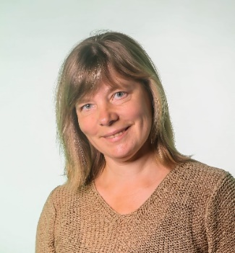 | Dr.agr. Liena Poiša, e-mail: sfi@rta.lv  Assistant professor at the Rezekne Academy of Technologies, Latvia ORCID: https://orcid.org/0000-0002-6031-7718  Research interests: Oilcrop: hemp, linseed. Protein and starch content in crop. Growing environmentally friendly products. Beekeeping and beeproducts quality. Crops chemical content. Environmental Pollution. Heavy metals.
 | Dr. sc. ing. Artis Teilāns  Professor at the Rezekne Academy of Technologies, Latvia.  ORCID: https://orcid.org/0000-0003-3185-9451  Research interests: Industrial automation, Domain specific software development, Sensor data processing.
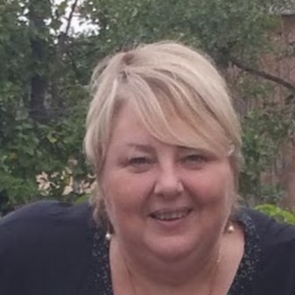 | Mg. paed. Inese Silicka  Director of the first-level professional higher education study program "Food Product Processing" in Rezekne Academy of Technologies, Latvia  Researcher in the Business and Society Processes Research Institute  ORCID: https://orcid.org/0000-0002-8881-7431  Research interests: Food production. Food tourism. Food economics

* Corresponding author. Tel.:+371-00000000. E-mail address: e-mail@rta.lv

